FVDI J2534 Brief Introduction

- Functions

FVDI J2534 is a vehicle communication interface device that full compatible with SAE J2534-1 and partly compatible with SAE J2534-2. It supports most of vehicle communication protocols and can be used as PassThru device for many dealer level diagnostic software. And it can be used as a ELM327 device also, support most of ELM327 software.

Highlights

- High speed host communication. (3M bps)

- Stable host communication. (with RTS/CTS flow control)

- Automatically register software and no virtual machine needed.

- Online software update and keep software latest always.

- Online firmware update.

- USB/802.11 selectable host communication.

- Support ELM327 software by one device.

Comparison with other devices

- Ford/Mazda IDS

Function | FVDI  J2534 | Genuine  VCM II | Other  Devices | Comments
Automatically startup without license | ●
No virtual machine needed | ● | ●
Support online module programming | ● | ●
Support online PATS/RKE learning | ● | ●
Support SAE J1850 PWM 83.3K baud rate | ● | ●
Support FEPS 18V programming voltage | ● | ● | ●
Support FEPS 5~20V adjustable voltage | ● | ●
Support reading programming voltage | ● | ●
Support EEC-V multiple items data logger | ● | ● |  | MY 1994~2000 Ford
Support PTEC multiple items data logger | ● | ○ | ○ | MY 2000~2006 Ford
Support SAE J1850 module programming | ● |  |  | MY 1995~2006 Ford
Support power balance performance test | ● | ● |  | MY 1995~2006 Ford
Support CANBUS module programming | ● | ● | ● | MY2006～2018 Ford
Support online software update | ● |  |  | Keep software latest
Calculate incode pre-2010 for free | ●

- Toyota TIS

Function | FVDI  J2534 | Genuine  OTC | Other  Devices | Comments
Automatically startup without license | ●
No virtual machine needed | ● | ● | ●
Support ISO15765 vehicle diagnostic | ● | ● | ●
Support ISO14230 vehicle diagnostic | ● | ● |  | MY1995~2006 Toyota
Support online software update | ● |  |  | Keep software latest
Calculate smart system reset PIN for free | ●
- Honda HDS

Function | FVDI  J2534 | Genuine  HIM | Other  Devices | Comments
Immobi learning without password | ●
Smart card learning without password | ●
USB connection to PC, no RS232 needed | ● |  | ●
Support SCS short to ground | ● | ●
Support clearing DTC of ABS, SRS | ● | ●
Support VTEC learning | ● | ●
Immobi system menu available | ●
Support online software update | ● |  |  | Keep software latest

Technical specifications

- Voltage & Current requirements

8~32VDC, 100 mA (max), 0.6 Watts @ 12 VDC Note: protected against reverse battery polarity
- Vehicle Protocols ISO9141 ISO14230
J1850 VPW

J1850 PWM(Ford SCP) ISO11898 HS(500K BPS) ISO11898 MS(125K BPS) ISO15765 HS(500K BPS) ISO15765 MS(125K BPS)
FEPS(Flash EEPROM Program Signal) Honda SCS
Honda DIAGH KWP1281 J2819(TP2.0)
- Supported software for J2534 Ford IDS V110
Mazda IDS V108 Toyota TIS V13.00 Honda HDS V3.102
Land Rover/Jaguar SDD2 V153

Nissan CONSULT III plus R2R V80.11

- Supported software for ELM327 ELMconfig
Forscan FOCCCUS FF2
- Vehicle Connection Molded DLC3(OBDII-16)
- Dimensions

H:22mm (0.87in) W:54mm (2.13in) L:76mm (2.99in)

- Weight

50g (1.76oz)

- Environmental

Operating: -20ºC to 45ºC (-4ºF to 113ºF) at 15% to 85% RH non-condensing

Appearance details

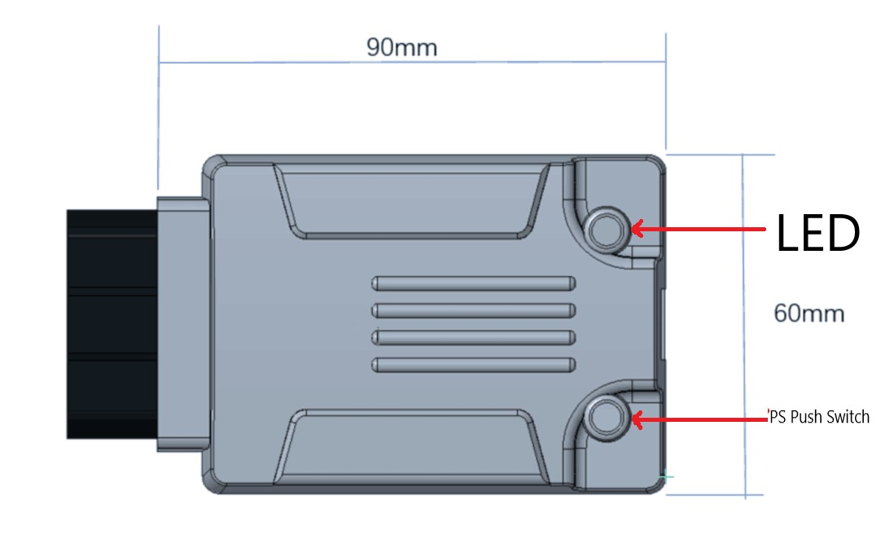

LED:

Work normal: Green LED blinks continuously slowly Firmware updating: Red LED blinks continuously quickly
PS Push Switch:

Pressed: works as ELM327 mode Released: works as J2534 mode

