EasyCoding User Manual

Table of contests
1. Software operating system 2
2. Software download and installation 2
2.1 Software download 2
2.2 Software installation 2
3. Product instruction 6
3.1 Parts 6
3.2 EasyCoding Function 6
4. Connection mode 9
4.1 The position of vehicle diagnosis socket 9
4.2 Connection mode of ENET 10
5. Software operation manual 10
5.1 Software operating environment 10
5.2 Vehicle condition 10
5.3 Internet condition 11
6. Operating software 11
6.1 Diagnostic function 12
6.2 DTC 13
6.3 Customization 13
6.3.1 Common mode 14
6.3.2 Expert Mode 16
7. Options 19
8. Registration 19
9. Upgrading 19
10. Help 19
11. Service 19
11.1 Guarantee clause 19
11.2 Feedback 19

Software operating system
- Requirements for hardware: laptop, PC, PAD. Space of system disk is no less than 5G, and RAM is no less than 2G.
- Operating system: Supporting WINDOWS XP SP3, WIONDOWS 7 and WIONDOWS 8, but not WINDOWS RT.
- Requirements for internet: The software needs to be upgraded online, please make sure your internet is connected.
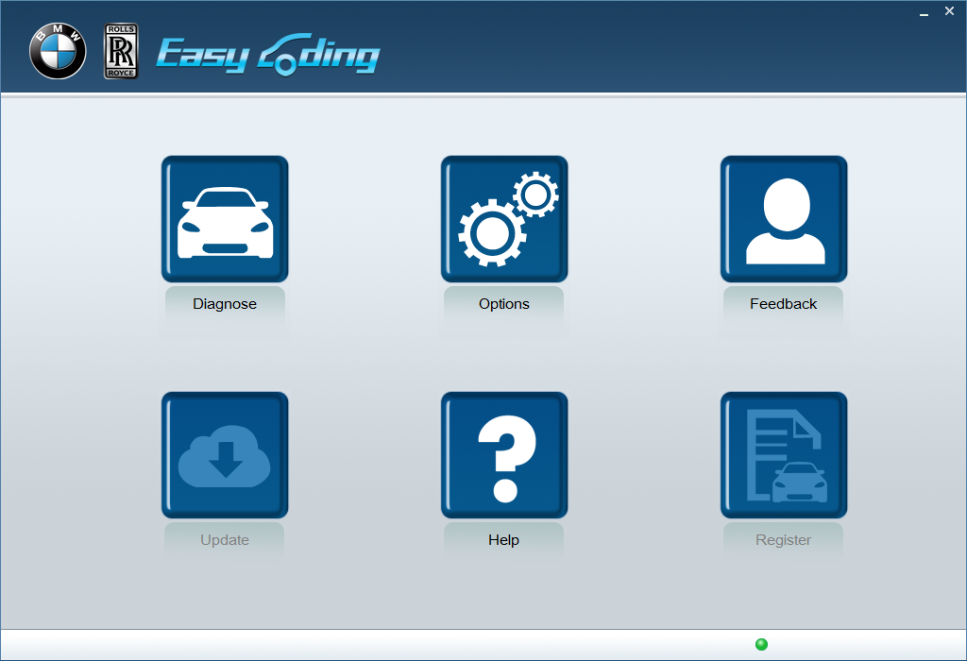

2. Software download and installation

2.1 Software download
Log in http://www.euseauto.com and download EasyCoding_setup_V1.0 installation package.

2.2 Software installation
Decompress EasyCoding_setup_V1.0 package and release the folder setup.exe or you can find setup.exe from manufacturer’s Sandisk. The following is an example:
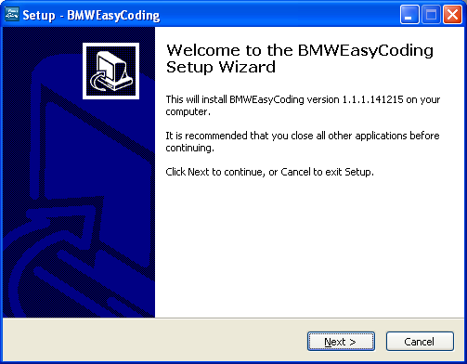
Press 【Next】
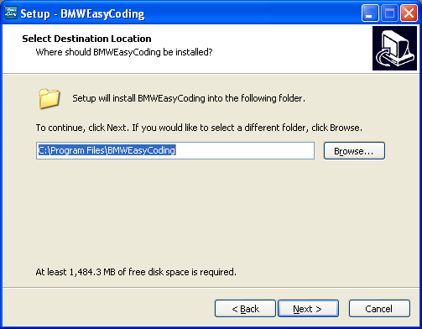
Press 【Next】
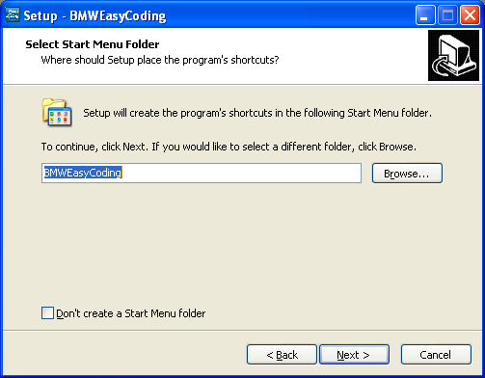
Press 【Next】
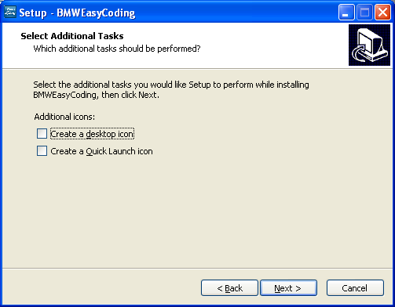
Choose “Create a desktop icon” and then press 【Next】
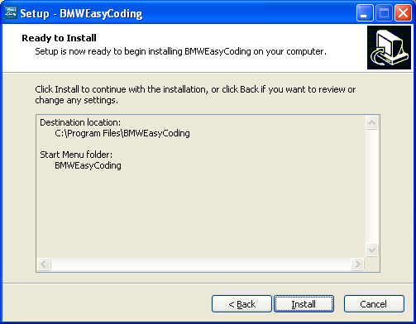
Press 【Install】
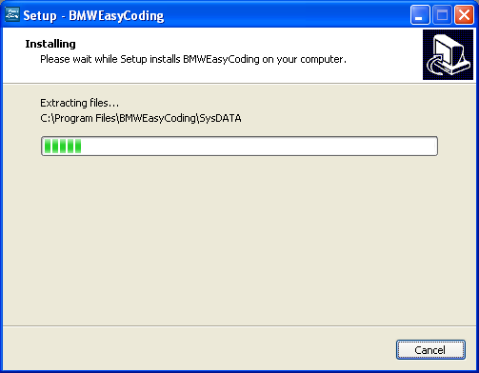
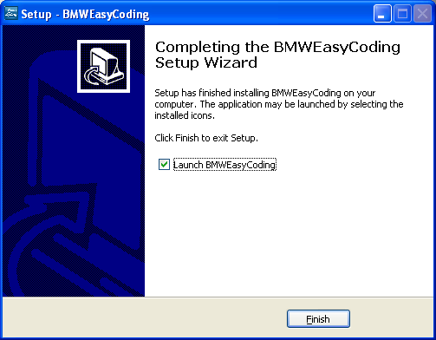
Press 【Finish】to operate “EasyCoding”
If Superdog is not inserted, the following information will pop up.
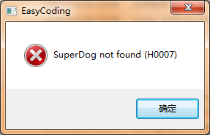
If Superdog is inserted, you will enter software application interface.

3. Product instruction

3.1 Parts
Number | Picture | Name | Function
1 | 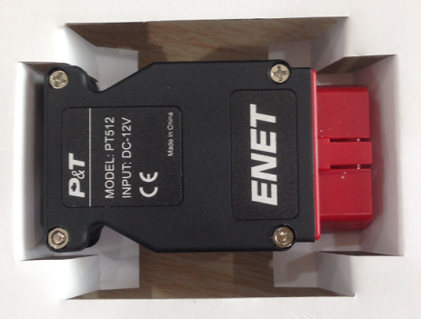 | ENET Contactor | Connect OBD diagnosis socket
2 | 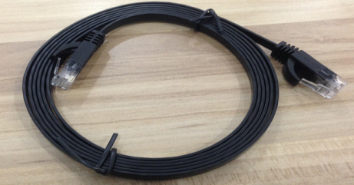 | Cable | Connect PC and ENET Contact
3 | 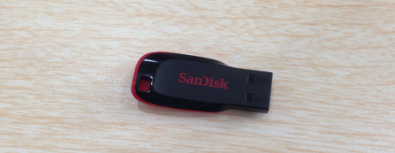 | USB Flash disk | EasyCoding installation software
4 | 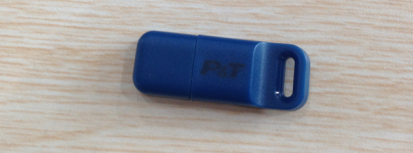 | Superdog | Superdog must be inserted in USB interface of your PC when applying EasyCoding

3.2 EasyCoding Function
EasyCoding is a newly developed device for reading BMW and Rolls-Royce fault codes and making vehicle personalized settings. Below is a list of car models and model years that it supports:
Dev. Platform | Car models | Year of made | Dev.  Platform | Car models | Year of made
F01 | BMW 7 Series Sedan | Oct. 2010 upwards | F31 | BMW 3 Series Wagon | Oct. 2012 upwards
F02 | BMW 7 Series Limo | Apr. 2009 upwards | F32 | BMW 3 Series Coupe | Dec. 2012 upwards
F03 | BMW 7 Series High Security | Nov. 2011 upwards | F33 | BMW 3 Series Convertible | May 2013 upwards
F04 | BMW 7 Series Hybrid | Apr. 2012 upwards | F34 | BMW 3 Series Gran Turismo | Mar. 2013 upwards
F06 | BMW 6 Series Gran Coupe | Jan. 2013 upwards | F35 | BMW 3 Series Gran Coupe (China Limo) | Aug. 2012 upwards
F07 | BMW 5 Series Gran Turismo | Dec. 2012 upwards | F36 | BMW 4 Series Coupe | Sep. 2013 upwards
F10 | BMW 5 Series Sedan | Jun. 2009 upwards | F55 | MINI Cooper | Feb. 2014 upwards
F11 | BMW 5 Series Wagon | Apr. 2011 upwards | F56 | MINI Cooper | Jan. 2014 upwards
F12 | BMW 6 Series Convertible | May 2012 upwards | F80 | M3 4-Door Sedan | Apr. 2014 upwards
F13 | BMW 6 Series Coupe | Mar. 2012 upwards | F82 | M3 2-Door Coupe | May 2014 upwards
F15 | BMW X5 M Sport | May 2014 upwards | F83 | M3 Convertible | Apr. 2014 upwards
F16 | BMW X6 Sports Activity Croup | Mar. 2014 upwards | F85 | BMW X5 M SUV | Mar. 2014 upwards
F18 | BMW 5 Series Sedan (China Limo) | Oct. 2010 upwards | F86 | BMW X6 M SUV | Feb. 2014 upwards
F20 | BMW 1 Series Luxury Sedan | Jan. 2013 upwards | RR1 | Rolls-Royce luxury sedan series II | Nov. 2002 upwards
F21 | BMW 1 Series Sedan | Oct. 2012 upwards | RR2 | Rolls-Royce Corniche Convertible II | Jun. 2006 upwards
F22 | BMW 1 Series Sedan | Jan. 2014 upwards | RR3 | Rolls-Royce luxury sport cars series II | Aug. 2011 upwards
F23 | BMW 1 Series Convertible | Apr. 2014 upwards | RR4 | Rolls-Royce luxury sedan | May 2015 upwards
F25 | X3 SUV | Jan. 2011 upwards | RR5 | Rolls-Royce Ghost | Feb. 2014 upwards
F26 | X4 SUV | Jan. 2014 upwards | RR6 | Rolls-Royce Convertible | Feb. 2014 upwards
F30 | BMW 3 Series Gran Coupe | Sep. 2011 upwards
Table 1. EasyCoding car model and model year list
Personalization functions please see Table 2. Personalization function list.
Note: To check out if some functions are available on specific cars, please look up that car’s settings according to the table below. These functions vary from vehicle to vehicle. Because of different hardware configuration, some functions may not available on certain cars.
# | System | Function
1 | HU | Add Select Sound Effects Of Lock/Unlock In I-drive
 |  | Operate Navigation Menu And Watch DVD During Driving
 |  | Enable Efficient Dynamics Sport CID (Added Sport Displays The Vehicle Info Screen (Power & Torque Meters)).
 |  | Disable iDrive Legal Disclaimer During iDrive Startup
 |  | Select Sports Mode In I-drive
 |  | Turn On Gasoline Station Alert In Navigator
 |  | Allow PDC(Park Distance Control) To Indicate Park Distance
 |  | Disable Daytime Running Lamps
 |  | Convert kilometers To Miles
 |  | Increase The FM band
 |  | Disable Handbrake To Play Videos
 |  | Disable Reversing Camera Warning Window
 |  | Video Playing With USB Are Available In 2013 NTB
2 | ACSM | Set Seat Belt Alarm To Last 10 Seconds
3 | BDC | Allow Car Windows To Roll Up Without Being Disturbed By Door Openings
 |  | Activate/Deactivate Headlight Washer
 |  | Set Car's Auto Start/Stop To Start In The Last Used Setting (e.g. Off) When The Engine Is Started
4 | CAS | Central Control Unlock Automatically When Engine Is Off
 |  | Shorten Time To Roll Up Or Down Car Windows
 |  | Shorten The Time To Fold Down Rearview Mirrors
5 | Combox | Voice Recognition
 |  | Play Videos
 |  | Add CIC stored addresses/messages from 25 to 50
 |  | Microphone Settings
 |  | Change and Synchronize Incoming Call Ringtones On Bluetooth Device
6 | DWA8 | Set Lock Alarm Sound To The Maximum
7 | FEM | Allow Car Windows To Roll Up Without Being Disturbed By Door Openings
 |  | Activate/Deactivate Headlight Washer
 |  | Set Car's Auto Start/Stop To Start In The Last Used Setting (e.g. Off) When The Engine Is Started
8 | FKA | AC Records Last Engine-off Statues
9 | FRM | Allow Car Windows To Roll Up Without Being Disturbed By Door Openings
 |  | Auto Control Of High Beams
 |  | Extend Foot To Open Rear Cover
10 | FZD | Set Lock Alarm Sound To The Maximum
11 | IHKA | AC Records Last Engine-off Statues
 |  | AC Air Circulation Records its Engine-off Statues
12 | TCU | Microphone Settings
13 | JBBFE | Allow Car Windows To Roll Up Without Being Disturbed By Door Openings
 |  | Activate/Deactivate Headlight Washer
 |  | Wiper Resets Automatically
 |  | Disable Front Camera At Maximum Distance
 |  | Disable Back Camera At Maximum Distance
14 | KOMBI | Display Digital Vehicle Speed
15 | PMA | Disable Front Camera At Maximum Distance
 |  | Disable Back Camera At Maximum Distance
 |  | Disable Front Camera At Maximum Speed
 |  | Disable Back Camera At Maximum Speed
16 | RADIO | Add Select Sound Effects Of Lock/Unlock In I-drive
 |  | Operate Navigation Menu And Watch DVD During Driving
 |  | Disable Daytime Running Lamps
 |  | Increase The FM band
17 | RSE | Add Select Sound Effects Of Lock/Unlock In I-drive
 |  | Operate Navigation Menu And Watch DVD During Driving
 |  | Enable Efficient Dynamics Sport CID (Added Sport Displays The Vehicle Info Screen (Power & Torque Meters)).
 |  | Disable iDrive Legal Disclaimer During iDrive Startup
 |  | Select Sports Mode In I-drive
 |  | Turn On Gasoline Station Alert In Navigator
 |  | Allow PDC(Park Distance Control) To Indicate Park Distance
 |  | Disable Daytime Running Lamps
 |  | Convert kilometers To Miles
 |  | Increase The FM band
 |  | Disable Handbrake To Play Videos
18 | ULF | Voice Recognition 2
 |  | Select Bluetooth Phone Ringtone
 |  | Change and Synchronize Incoming Call Ringtones On Bluetooth Device
Table 2. Personalization function list

4. Connection mode

4.1 The position of vehicle diagnosis socket
The OBD diagnosis socket is usually below instrument panel in the driving side. For example, the diagnosis socket of BMW 1 series is situated at driver door frame, and the cover is marked “OBD”. When uncovered, you can see OBD diagnosis socket.
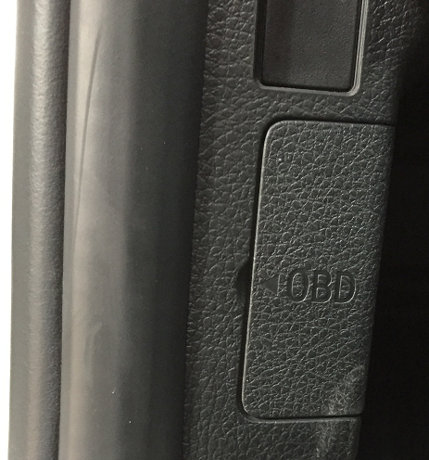
Picture1. OBD diagnosis socket of BMW 1 series
The OBD diagnosis socket of BMW 3 series, BMW 5 series and BMW 7 series is below instrument panel in the driving side.
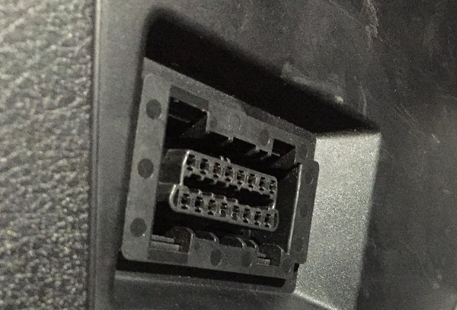
Picture2. OBD diagnosis socket of BMW 3 series
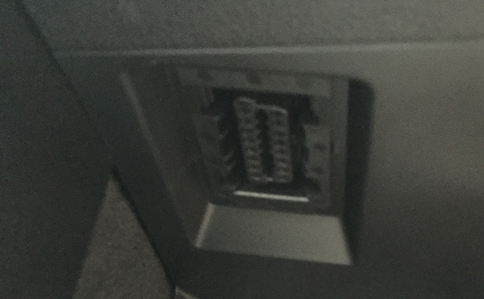
Picture3. OBD diagnosis socket of BMW 5 series
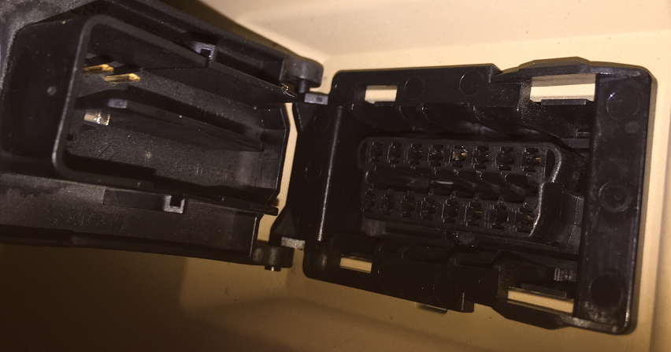
Picture4. OBD diagnosis socket of BMW 7 series

4.2 Connection mode of ENET
Plug ENET connecter into the OBD diagnostic port of the car. The indicating light on the connector will turn on, indicating that the OBD port is providing a stable power supply, as shown in Picture 5. If the light is not on, please check if there is a bad ENET connection. Then connect the networking cable to the ENET connector. Once the connection is built, the EasyCoding software is ready to use.
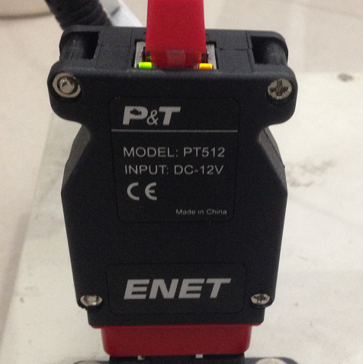
Picture5. Connection mode of ENET

5. Software operation manual

5.1 Software operating environment
System requirement: WINDOWS operating system, Windows XP SP3，Windows 7，Windows 8.

5.2 Vehicle condition
Make sure the vehicle battery is in good condition. The voltage is above 12V, and there is electricity loss. Turn on ignition switch but do not start the vehicle and turn off other electric appliances on the car.

5.3 Internet condition
Please check the Cable Network Setting in your computer and configure your computer to obtain an IP address automatically instead of using an assigned IP address.
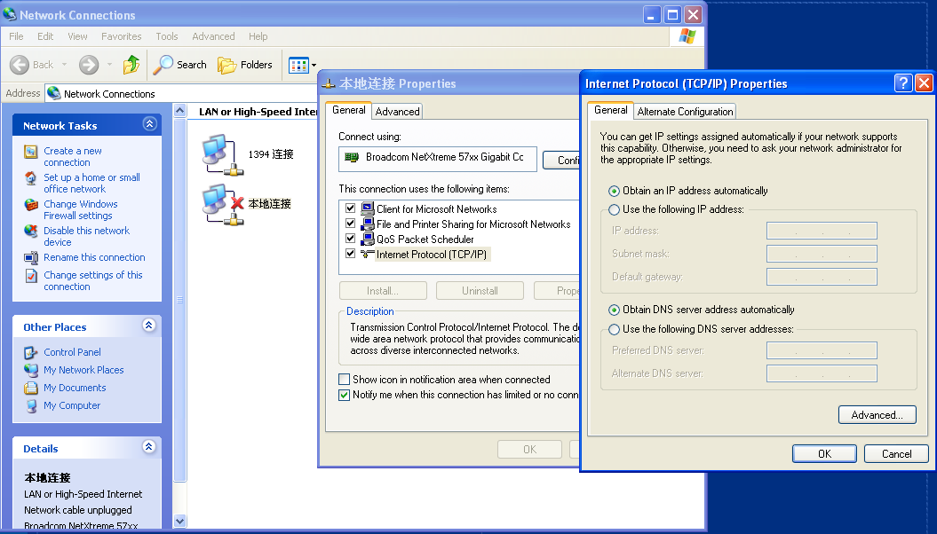
Picture6

6. Operating software
Insert Superdog to the USB interface of your computer. It’s unnecessary to install any drive. Double click EasyCoding icon on desktop to operate the software.
Picture7

6.1 Diagnostic function
When network status icon on the lower right corner of computer stops circling an exclamation mark appears, you can click the software diagnostic icon.
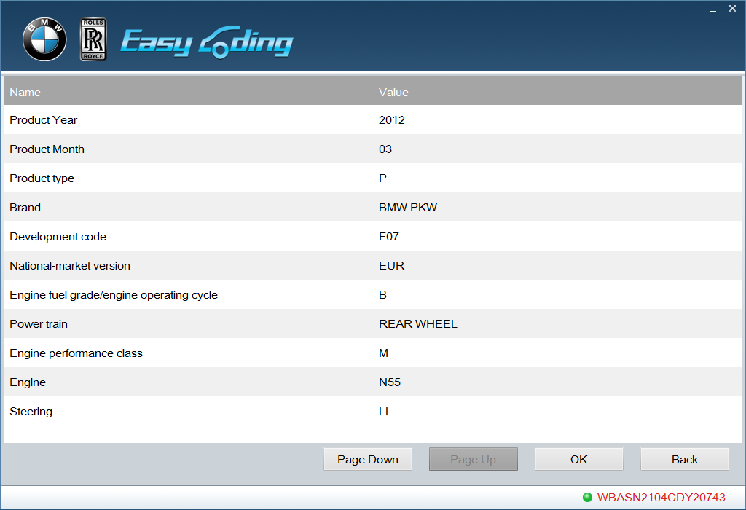
Picture 8
The software reads vehicle VIN code automatically and displays vehicle information. If the vehicle information is not shown, you need to contact the supplier for the latest vehicle data.
Press [Page Down] to display full vehicle information; Press [Back] can return to previous menu; Press [OK] to entering into Sub-menu.
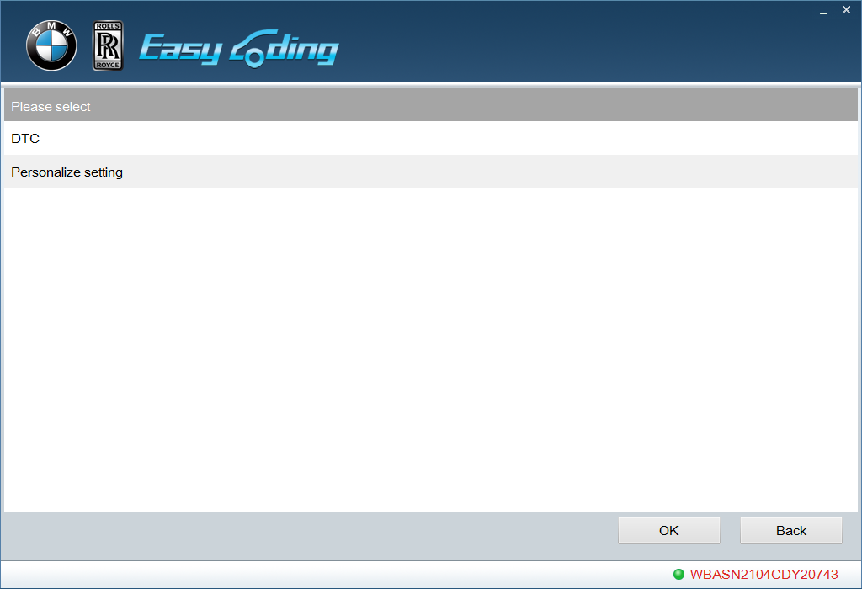
Picture9
Two major diagnostic functions: “DTC” and “Customization”。

6.2 DTC
The function of diagnosing DTC can scan all DTCs existing in electric system. Please confirm there is no DTC stored before customization. Historical DTCs and sporadic DTCs can be cleared by clearing function, but permanent DTCs indicate DTCs exist in vehicle and can’t be cleared. Please confirm whether further maintenance is needed.
After customization, you can check whether there is DTC information stored in the car. If there is new DTC information, then the customization is not suitable this vehicle. Please restore the modified customization.
Click DTC menu as follows:
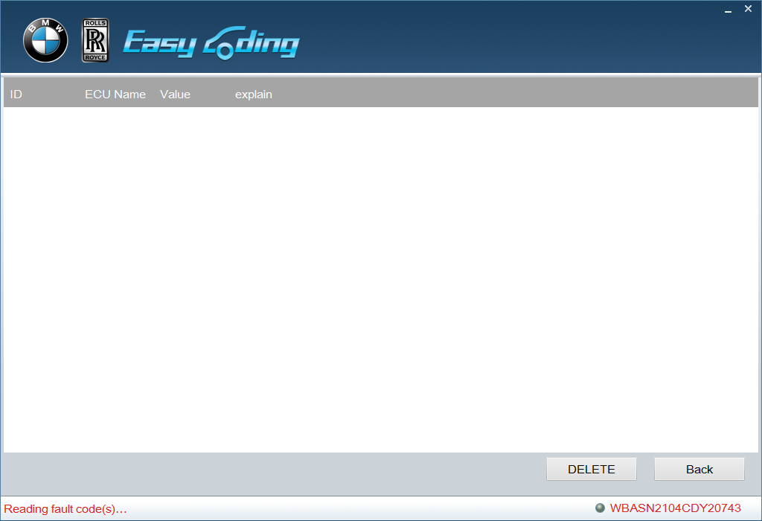
Picture10
Click [Delete] can clear all DTCs. After clearance, click [Back] and operate DTC clearing function again to confirm whether DTC information exists or not.

6.3 Customization
Choose customization menu and click [OK] to entering into customization interface.
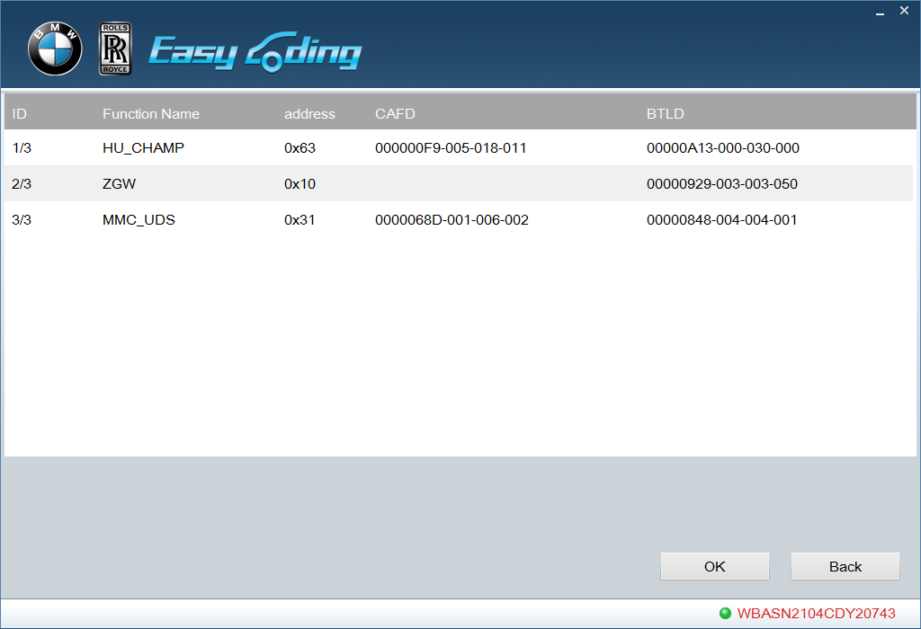
Picture11
This interface is an example of a car which displays all systems.
Note: sometimes the lists may not be complete because of radio communication mechanism. When this happened, please return and reenter into the interface.
Choose a system. Take HU as an example. Click [OK] to get into mode selection menu.
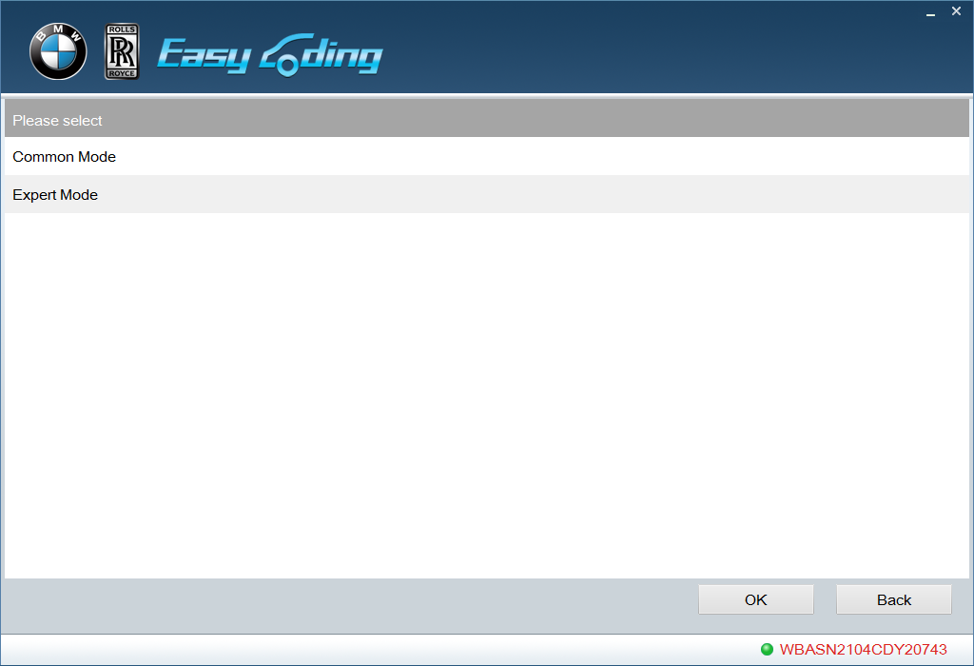
Picture12

6.3.1 Common mode

Click “Common Mode” and the functions that can be modified in the system are shown. You can refer to chart 2: customization chart to select common functions for relevant system according to function lists. Different vehicle models may correspond to different systems.
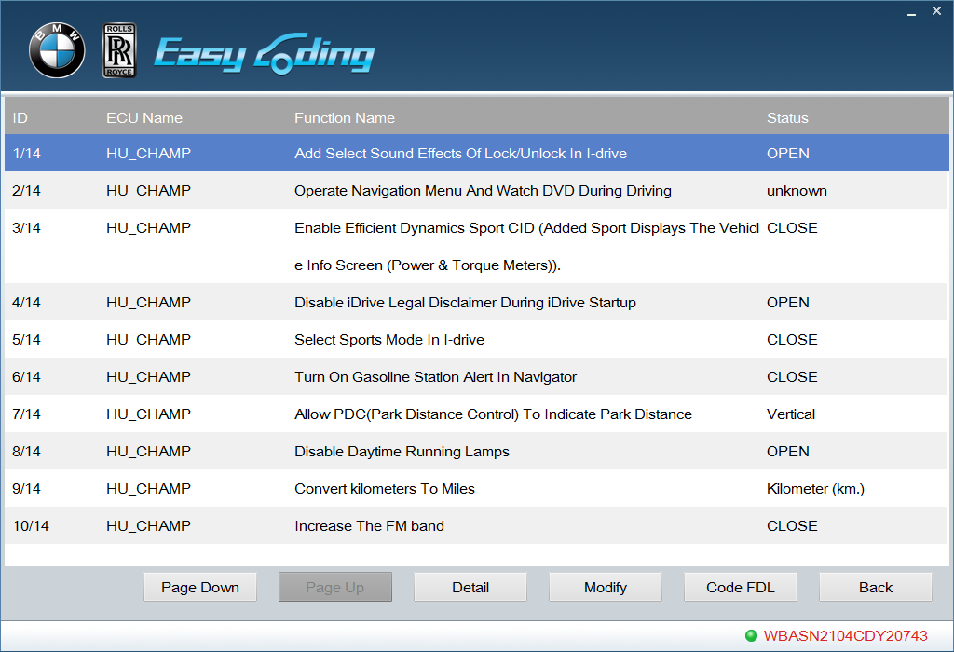
Picture13
Take “Select sound effects of Lock/Unlock in I-drive” as an example to introduce modifying operation in common mode. Click “Select sound effects of Lock/Unlock in I-drive”, and the current state is “close”. Click [Modify] and this function will show“open”. Then click [Code FDL], as shown in picture 14.
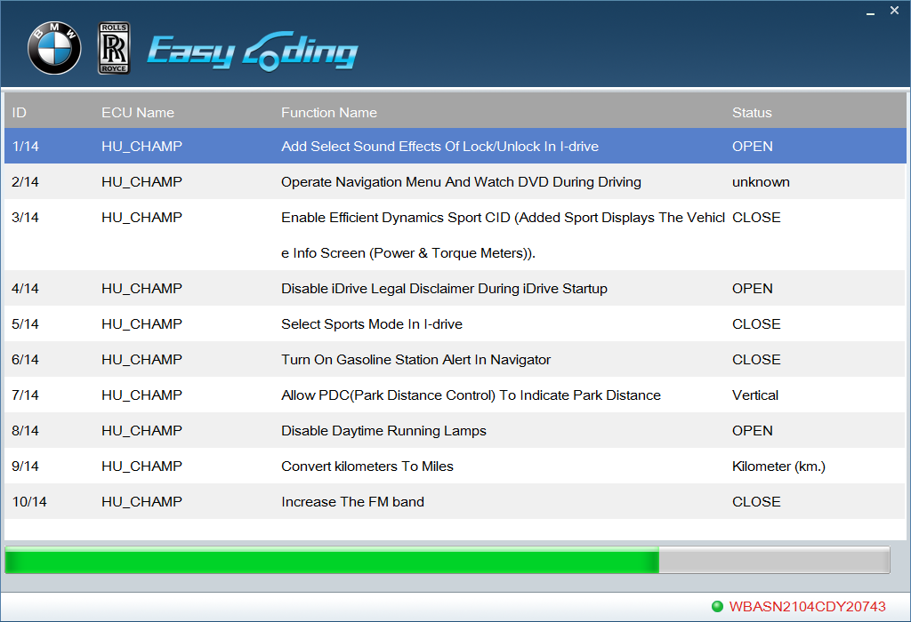
Picture 14
When code is set, common function is modified successful. But it still needs to be set in “idrive”. The process is shown as picture 15 and picture 16.

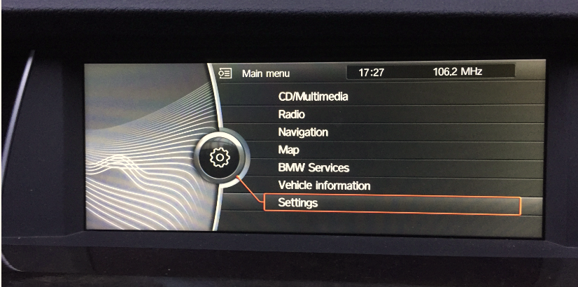
Picture 15
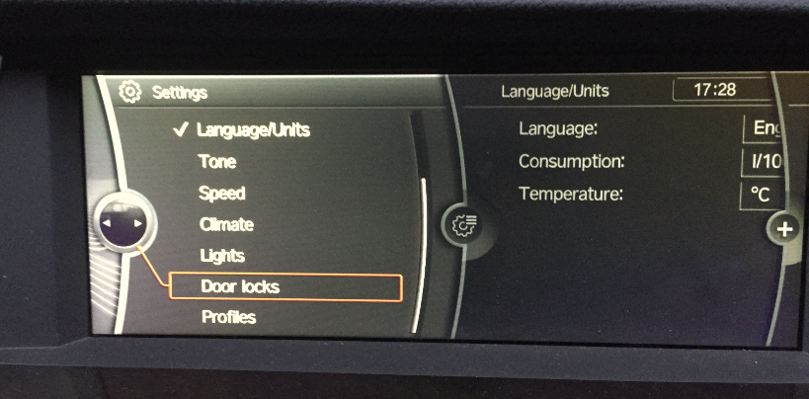
Picture 16
Another option in “Door Lock”is added, that is “Sound Effects of Lock/Unlock”. Check this option and you can test the sound effects of lock/unlock. If the sound is too small, you can modify the volume in common mode.

6.3.2 Expert Mode
Some functions may require system parameters to be modified or sometimes you may not find the functions you want, in “Common Mode”, then you will need “Expert Mode”. There are posts of opening expert functions in BMW forums. You can modify parameters referring to those posts and modify the functions you want in “Expert Mode”. System name, parameter and reflash hidden code table are the same, but we haven't tested yet.
Click “Expert Mode” to entering into parameter searching interface. The process is shown as picture 17.
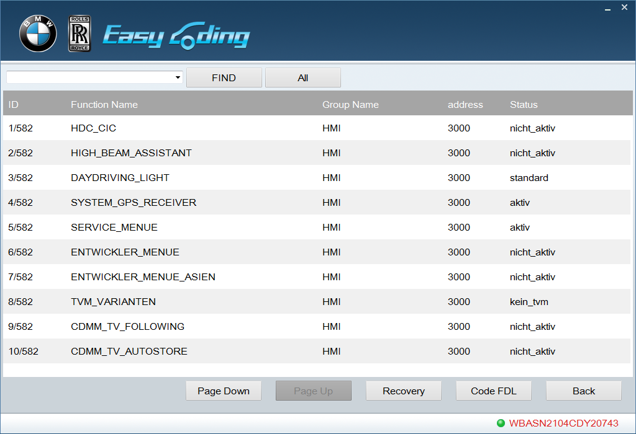
Picture 17
Please input the desired parameter in input box.
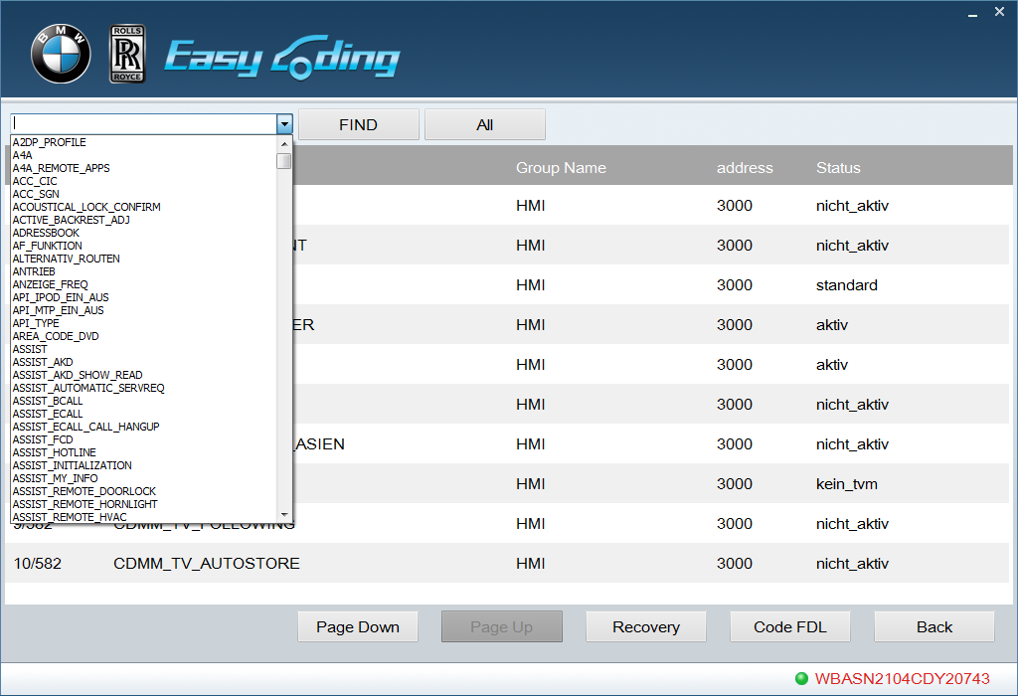
Picture 18
Find the desired parameter, and click the parameter line with left mouse button. As shown in picture 19, there are 3 options, choose the desired state or input customized value.
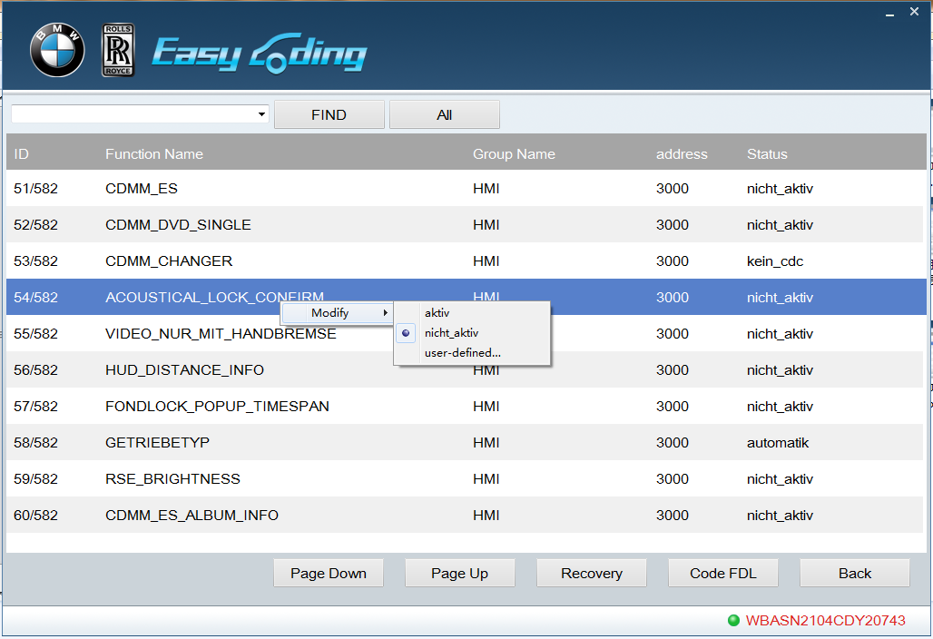
Picture 19
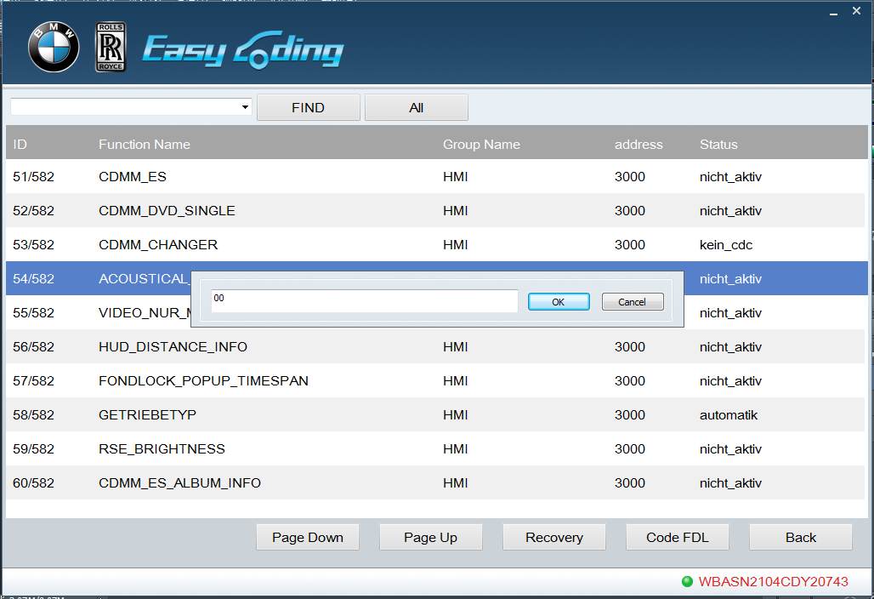
Picture 20
After change setting, click “Code FDL”
Note: "Custom" default uses the hexadecimal format, for example, decimal 1 equals to hexadecimal 0 x01, you can enter 0 x01 or 01; decimal 10 equals to hexadecimal 0x0A, you can enter 0x0A or 0A.
Expert Mode also provides "Recovery" function. If any fault code is generated when modifying certain system parameter and the code cannot be erased, that indicates this function is not available for your car. By this time you need to use recover function, it can restore your vehicle the raw data. Generally, choose the earliest system parameter to recover, see Picture 21.
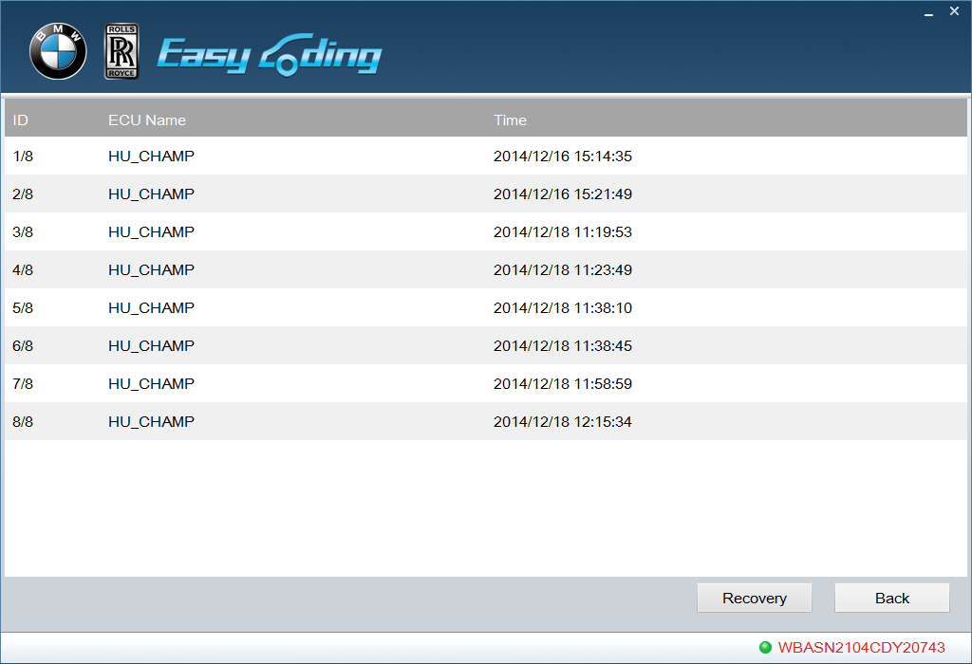
Picture 21

7. Options
This function is used to display software version and to select languages.

8. Registration
Registration is not needed for this version.

9. Upgrading
Online upgrading is not supported at present. Please pay attention to upgrading information on www.euseauto.com. There are at least 3 upgrades each year, including vehicle model database, code setting database, new common function settings and software optimizing.

10. Help
Click “Help” to entering into help interface and to guiding you operate the software correctly.

11. Service

11.1 Guarantee clause
One-year free replacement for the hardware of EasyCoding and two-year free upgrade for EasyCoding.

11.2 Feedback
You can send any question or advice to the email, euseauto@g163.com.

