CN900mini（English Version）
How to register TOY OBD
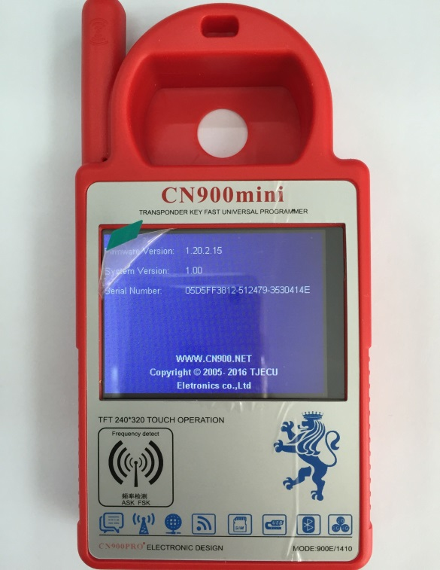Pic1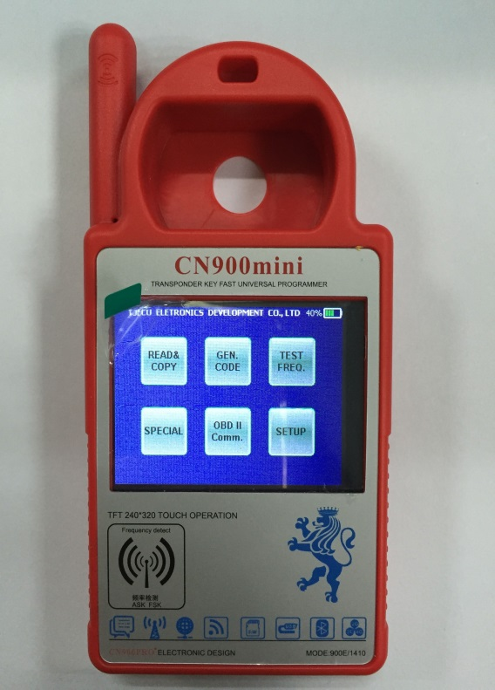Pic2
Step 1: connect Cn900mini to PC, and updated to Ver1.20.2.15(Pic 1), then back to CN900 mian interface(Pic 2), clike”OBDII Comm.”
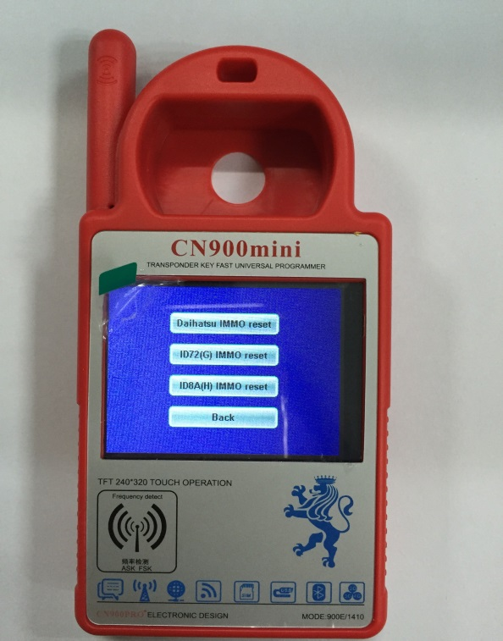Pic 3
Step 2： Click”ID72(G) IMMO reset”(pic3)
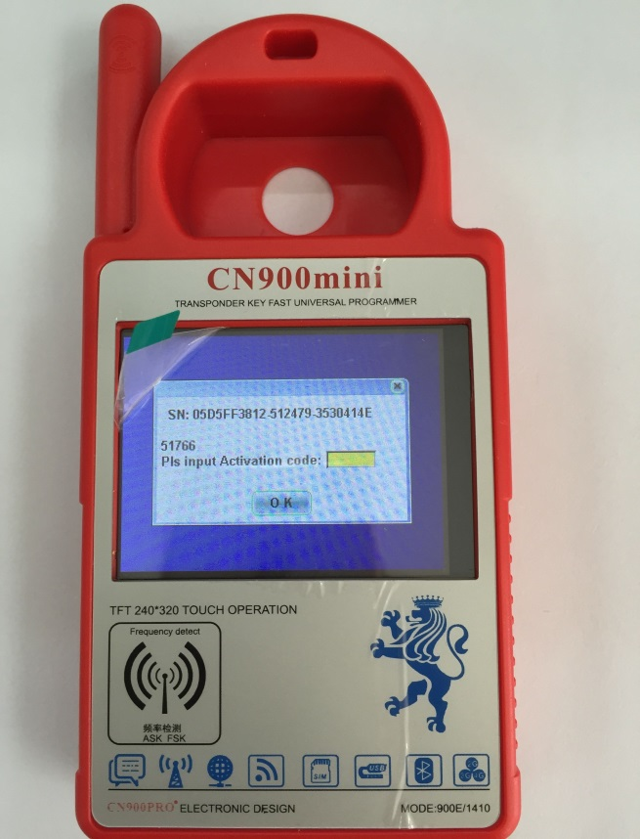（Pic 4）
Step 3： Cn900mini mian interface display as pic4， please take a photo of this and send to the salesmen which you contact, our salesmen will send this picture to our engineer, they will calculate the activation code; after the customer get the activation code and insert, it will register successfully.

Remark: one activation code just can register one CN900mini machine, it can not register many cn900mini, please operate according this user manual, If the customer does not operate in accordance with the instructions of the machine damage to a series of problems, customers have to bear the cost of freight and maintenance.

